**Mid–Point Ellipse Drawing Algorithm**

An ellipse is defined as the set of points such that the sum of the distances from two fixed point/positions (foci) is same for all points.

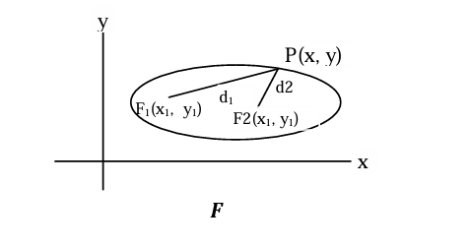

Fig: Ellipse

(x – xc)2 (y – yc)2

**General equation:** rx2 + ry2 = 1

**Mid-Point Ellipse Algorithm**

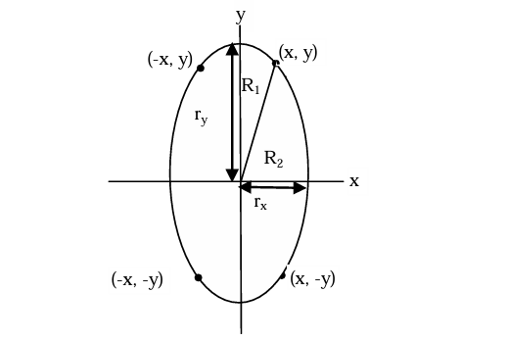

Fig: Ellipse with symmetry points

An ellipse has 4 way symmetry i.e. symmetric in quadrant only. So, we have to find the coordinate of a complete quadrant to use symmetry properties to plot the whole ellipse. Each quadrant is divided into two regions. The slope of curve in region 1 is lesser than -1. The slope of curve in region 2 is greater than -1. In region 1 we increase unit step in x direction and we determine whether to decrease or not in y direction. In region 2 we decrease unit step in y direction and we determine whether to increase or not in y direction.

Here, we start at position (0, ry)

we define an ellipse function with (xc, yc) = (0,0)

fellipse (x,y) = ry2x2+rx2y2-rx2ry2 ……..(i)

With properties

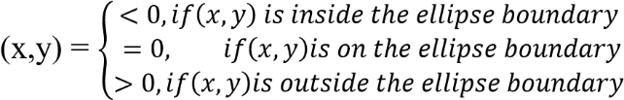

fellipse

Thus ellipse function serves as the decision parameter.

• At each sampling position, we select the next pixel along the ellipse path according to the sign of the ellipse function evaluated at the midpoint between the two candidate pixels.

• At each step, we test the value of the slope of the curve,

• Slope can be calculated as: ry 2 x2 + rx2 y2-r x2 r y2

Differentiating with respect to x,

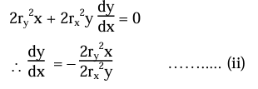

At the boundary between region 1 and region 2, slope =-1. So,

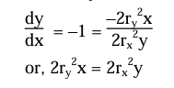

We move out of region 1, whenever

2r­y2x < 2rx2y

We move out from region 2, whenever

2ry2x < 2rx2y

Assuming (xk‑, yk) has been illuminated (selected) we determine the next position along the ellipse path by evaluating the decision parameter at the midpoint (xk+1, yk − 1/2 ).

We have to determine the next point is (xk+1, yk) or (xk+1, yk−1).

We define decision parameter at mid-point as

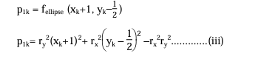

If p1k < 0, the mid-point is inside the ellipse and the pixel on scan line yk is closer to the ellipse boundary.

Otherwise, the mid-point is outside or on the boundary and we select the pixel on scan line yk-1.

At the next sampling position (xk+1 + 1 = xk +2), the decision parameter for region 1 is evaluated as

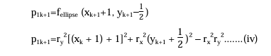

Subtracting equation (iii) from (iv),

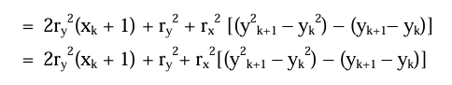

Where yK+1 is either yk or yk-1, depending on the sign of p1k If p1k≤ 0 i.e., yk+1 = yk, then decision parameter is p1k+1 = p1K+ 2rY2(xK +1) + rY2

If p1K>0 i.e.,yk+1 = yk– 1, then decision parameter is p1K+1 = p1k+ 2ry2(xk + 1) + ry2 – 2rx 2yk+1 The initial decision parameter is evaluated at start position (x0, y0) = (0, ry) as

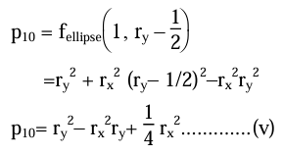

**Region 2**

We sample at unit step in the negative y direction and the midpoint is now taken between horizontal pixels at each step. The decision parameter is

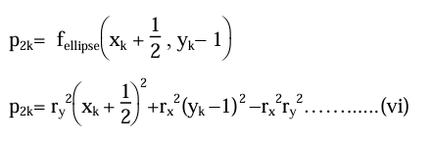

Put k = 0 for initial decision parameter for region 2

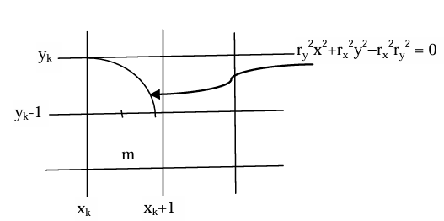

**Figure 2.10:** Midpoint in region 2

If p2k>0, the midpoint is outside the ellipse boundary and we select the pixel xk. Ifp2k, the midpoint is inside or on the ellipse boundary and we select pixel position xk+1.

Now, at next sampling position yk+1−1 = yk−2

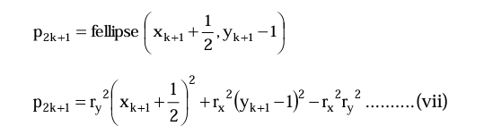

Subtracting equation (vi) from (vii)

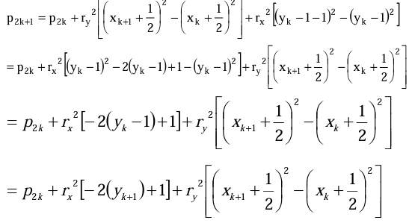

If p2k>0, then

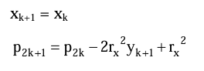

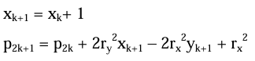

### Mid-point ellipse algorithm

|  |  |
| --- | --- |
| Step 1. | Start |
| Step 2. | Declare variables xc, yc, rx, ry, x,y,p0, pk, pk+1 |
| Step 3. | Read Values of xc, yc, rx, ry, |
| Step 4. | Obtain the first point on an ellipse centered on origin (x,y) by initializing the x and y as |
|  | x = 0 |
|  | y = ry |

Step 5. Calculate the initial value of the decision parameter in region 1 as



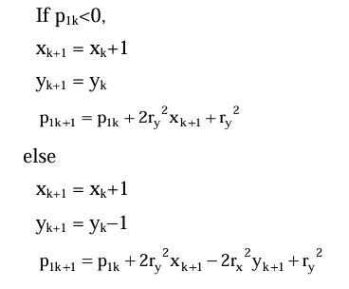Step 6. For each xk position in region 1, starting at k = 0, perform the following test.

Step 7. Calculate the initial decision parameter in region 2 using the last point (x0, y0) calculated in region 1 as

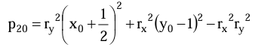

|  |  |
| --- | --- |
| Step 8. | At each yk position in region 2, starting at k = 0, perform the following test. |
|  | If p2k>0, |
|  | the next point along the ellipse centered on (0,0) is (xk, yk-1) and  xk+1 = xk |
|  | yk+1 = yk-1 |
|  | p2k+1 = p2k - 2rx2yk+1 +rx2 |
|  | else |
|  | the next point along the ellipse is |
|  | xk+1 = xk+1 |
|  | yk+1 = yk– 1 |
|  | p2k+1 = p2k +2ry2 xk+1 - 2rx2yk+1 +rx2 |
|  | Use the same incremental calculations for x and y as in region 1. |
| Step 9. | Determine the symmetry points in the other three quadrants. |

Step 10. Move each calculated pixel position(x, y) onto the elliptical path centered on (xc, yc) and plot the coordinate values.

x = x+ xc

y = y+ yc

Step 11. Repeat the steps for region 2 until y<0.

Step 12. Stop.